|  |  |
| --- | --- |
|  | |
|  | |
| [Report Title] | |
| **Module code:** | **[4 digit code]** |
| **Module name:** | **[Module name]** |
|  | |
| [Date of submission] | |
|  | |
| **Author(s):** | **[Author name]** |
| **Student ID(s):** | **[Number]** |
| **Degree:** | **[e.g. MEng Aerospace Engineering with Industry]** |
| **Tutor/Project supervisor:** | **[Name]** |
|  | |
| **CO-INVESTIGATOR: [Enter name here] [For 1st year labs only – delete this line for all other reports]** | |
| **SUPERVISOR’S COPY/EXAMINER’S COPY [For 3rd/4th year projects only - delete as appropriate] [Delete this line for all other reports]** | |

|  |
| --- |
|  |
| Summary |
| [Enter summary text here] |

Contents

1 Introduction {Paul} Real world applications , requirements 2

1.1 List of members 2

1.1 Chassis (Brad) 2

1.2 Design (Alex) 2

1.3 Powertrain (Keqi) 2

1.4 (Paul) 2

1.5 (Divine) 3

1.6 (Xiang) 0

2 The criteria derived from the specifications for the design to meet the system requirements and the rules; {Brad} 0

3 A requirement tree {Divine} 0

4 A morphological diagram or mind-map showing the range of solutions or devices considered for concepts; {Keqi} 1

5 A sketch and corresponding description of each concept presented in the first VDP meeting. The name of the "designer" should be written on the sketch together with some reference number or text to the synthesis chart 0

5.1 Chassis (Brad) 0

5.2 Design (Alex) 0

5.3 Powertrain (Keqi) 0

5.4 (Paul) 0

5.5 (Divine) 0

5.6 (Xiang) 0

6 Synthesis chart Sort of VDP2 {Do together on monday} 0

7 Materials & Pricing {Alex} 0

8 Conclusion on design After VDP2 {Xiang} does introductory paragraph 0

8.1 Chassis (Brad) 1

8.2 Design (Alex) 1

8.3 Powertrain (Keqi) 1

8.4 (Paul) 1

8.5 Divine Abraham - Electrical & Control Systems Engineer 1

8.6 (Xiang) 0

# Introduction {Paul} Real world applications , requirements

This template is designed to be used with the Department Technical Writing Handbook for students, which details the standards you are expected to follow. The section headings in this template are examples commonly used for a laboratory report. For project reports in later years, the section headings and structure of the report should be discussed with your supervisor, because they may be different, specially for software or control projects.

Examples of tables, figures, equations and examples of references for a textbook [1], journal paper [2] and webpage [3] are included which can be used as a template for these features in your report.

## List of members

## Chassis (Brad)

3-4sentences  
link back to spec

Roles and responsibility

## Design (Alex)

3-4sentences  
Roles and responsibility

## Powertrain (Keqi)

3-4sentences Roles and responsibility

## (Paul)

3-4sentences Roles and responsibility

## (Divine)

The electrical and control systems engineer is responsible for the design and implementation of the electrical and control systems. The individual has to work closely with the powertrain engineer to deliver a system that is capable of starting and stopping, using a standard radio control system. The system would get enough lift and be capable of overcoming small obstacles and shall travel at a minimum speed of 1.4 m/s.

## (Xiang)

3-4sentences Roles and responsibility

# The criteria derived from the specifications for the design to meet the system requirements and the rules; {Brad}

# A requirement tree {Divine}

Be able to lift off the ground

Change direction

Travel at a minimum speed

Fully Functional Hovercraft

Dimensions

Payload

Materials and manufacture

Safety

Have a payload area

Carry a minimum payload mass of 200g

Carry multiple payloads

Secure payload for restricted movement

Maximum length of 420 mm

Maximum width of 297 mm

Must be enclosed in cowling extending a minimum of 20 mm in front and 20 mm behind the plane of the propeller.

The flexible skirt, propeller, mechanical fixtures and drive components-purchased from university’ preferential suppliers

Control & Propulsion

50%

50%

30%

30%

40%

100%

100%

30%

15%

25%

30%

# A morphological diagram or mind-map showing the range of solutions or devices considered for concepts; {Keqi}

**Blaaaaaa**

**aaaaaaaaah;**

.

# A sketch and corresponding description of each concept presented in the first VDP meeting. The name of the "designer" should be written on the sketch together with some reference number or text to the synthesis chart

## Chassis (Brad)

## Design (Alex)

## Powertrain (Keqi)

## (Paul)

## (Divine)

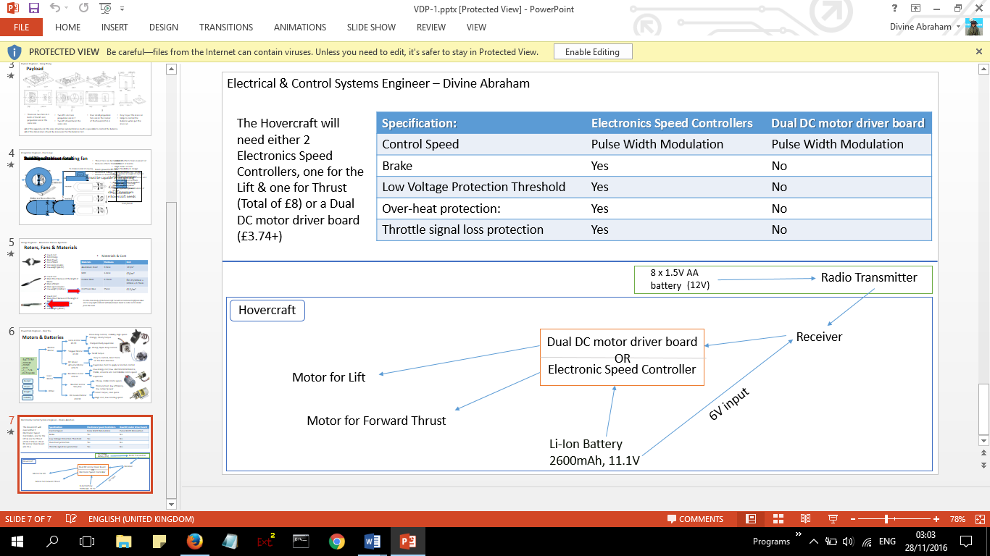At VDP1 there was an option to use either an electronic speed control (ESC’s) or a Dual DC motor driver board. The Dual DC motor driver board is cheaper and can control more fans than a single ESC. However after much research and feedback from the design professor it was decided that it would be a better idea to use the ESC’s over the latter as it was cost efficient, easy to work with and requires no additional components for a functioning system.

## (Xiang)

Calculatios (VDP2 stuff)

# Synthesis chart Sort of VDP2 {Do together on monday}

* **Completed synthesis chart ( or charts if a second iteration is attempted) showing:**
  + **The specifications considered;**
  + **The weightings for each criterion;**
  + **The marks for each design concept and the totals**

**Completed as a group**

**Bring every solid works design + sketches**

# Materials & Pricing {Alex}

Material Descision

# Conclusion on design After VDP2 {Xiang} does introductory paragraph

* **Concluding section stating the outcome of the selection process and giving outline details of the final design with the division of task to sub-groups.**

Picture of final design and more words

## Chassis (Brad)

## Design (Alex)

## Powertrain (Keqi)

## (Paul)

## Divine Abraham - Electrical & Control Systems Engineer

Following on from the feedback received from VDP2, It concluded that an additional circuit be mandatory which will be used to drive the fans in the opposite direction and get the hovercraft to reverse. The rechargeable battery will be directly connected to the electronic speed controllers (ESC’s) using the positive and negative terminals. There’s an intention to use a connector block to connect the nodes to multiple ESC’s . A connection to the motors will be made from the ESC’s and the correct voltage for the motors and servo will be dictated by the receiver which has a 3 pin connection to the ESC.

## (Xiang)